**Olympoid - CGI Report**

Boxing Robot Clown

Pragya Gurung (wq19451)

# **Concept Design**

## **1.1 Character Design - Robot Clown**

A mood board was created using images of robots found on websites such as Pinterest. The majority of the images are very cartoony and simple in terms of detail. Furthermore, rounded shapes were clearly preferred.

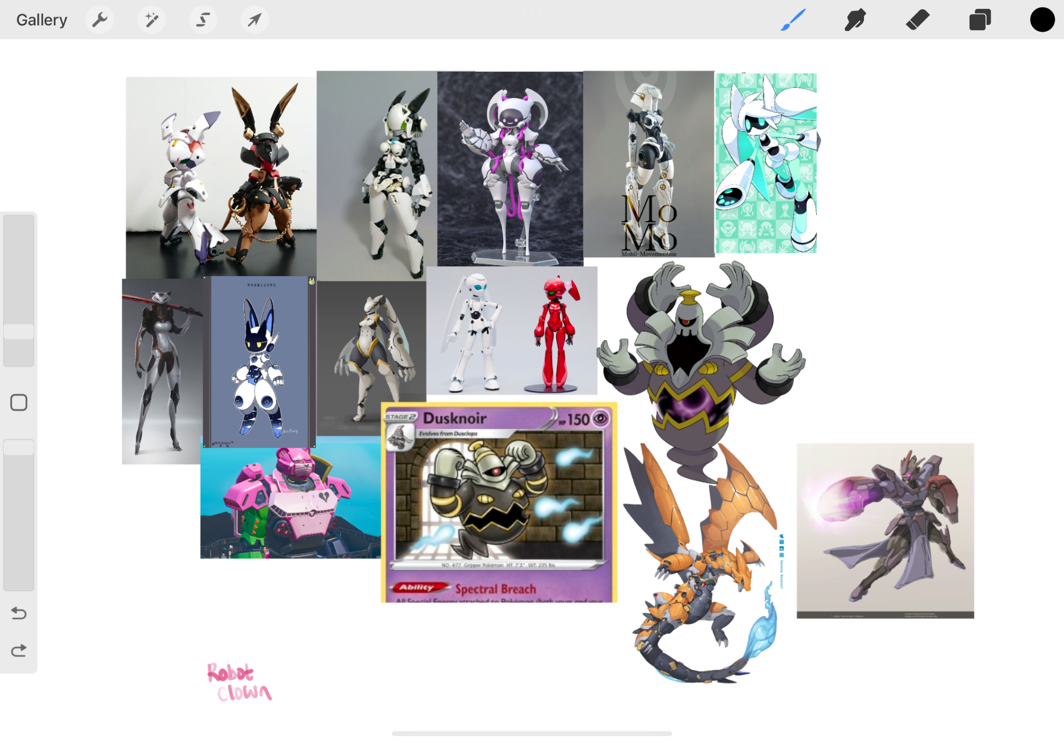

Figure Initial Moodboard.

The Olympoid's overall design was heavily influenced by the mega evolution of the Pokémon Dusknoir. Sketches were inspired by its spherical body and abnormally large hands, as shown in figure 2. Similar to the Pokémon, the Olympoid’s spherical body would be split into two by jagged edges. Splitting the body into two would hopefully allow for more movement in the “spine”. That is, the chest would be able to rotate independently of the hip area. Furthermore, inside the body would be a glowing ball with wires surrounding it - almost like an energy core.

Initial designs of the Olympoid were very humanoid, with two sets of arms and legs. However, after being inspired by an image of a cyborg black cat, the idea of the robot having a single animal-like hind leg became more appealing. This reference also influenced the design of the face; the Olympoid would have a feline-like face with glowing red eyes.

After more sketch iterations, the design began to feel very comical. This prompted further sketches to lean into that aspect, and an image of a clown was found online to serve as inspiration. The Olympoid was now a robotic clown as shown in figure 3. A large ruff collar was added around the neck of the Olympoid, along with some metallic buttons and a small top hat.

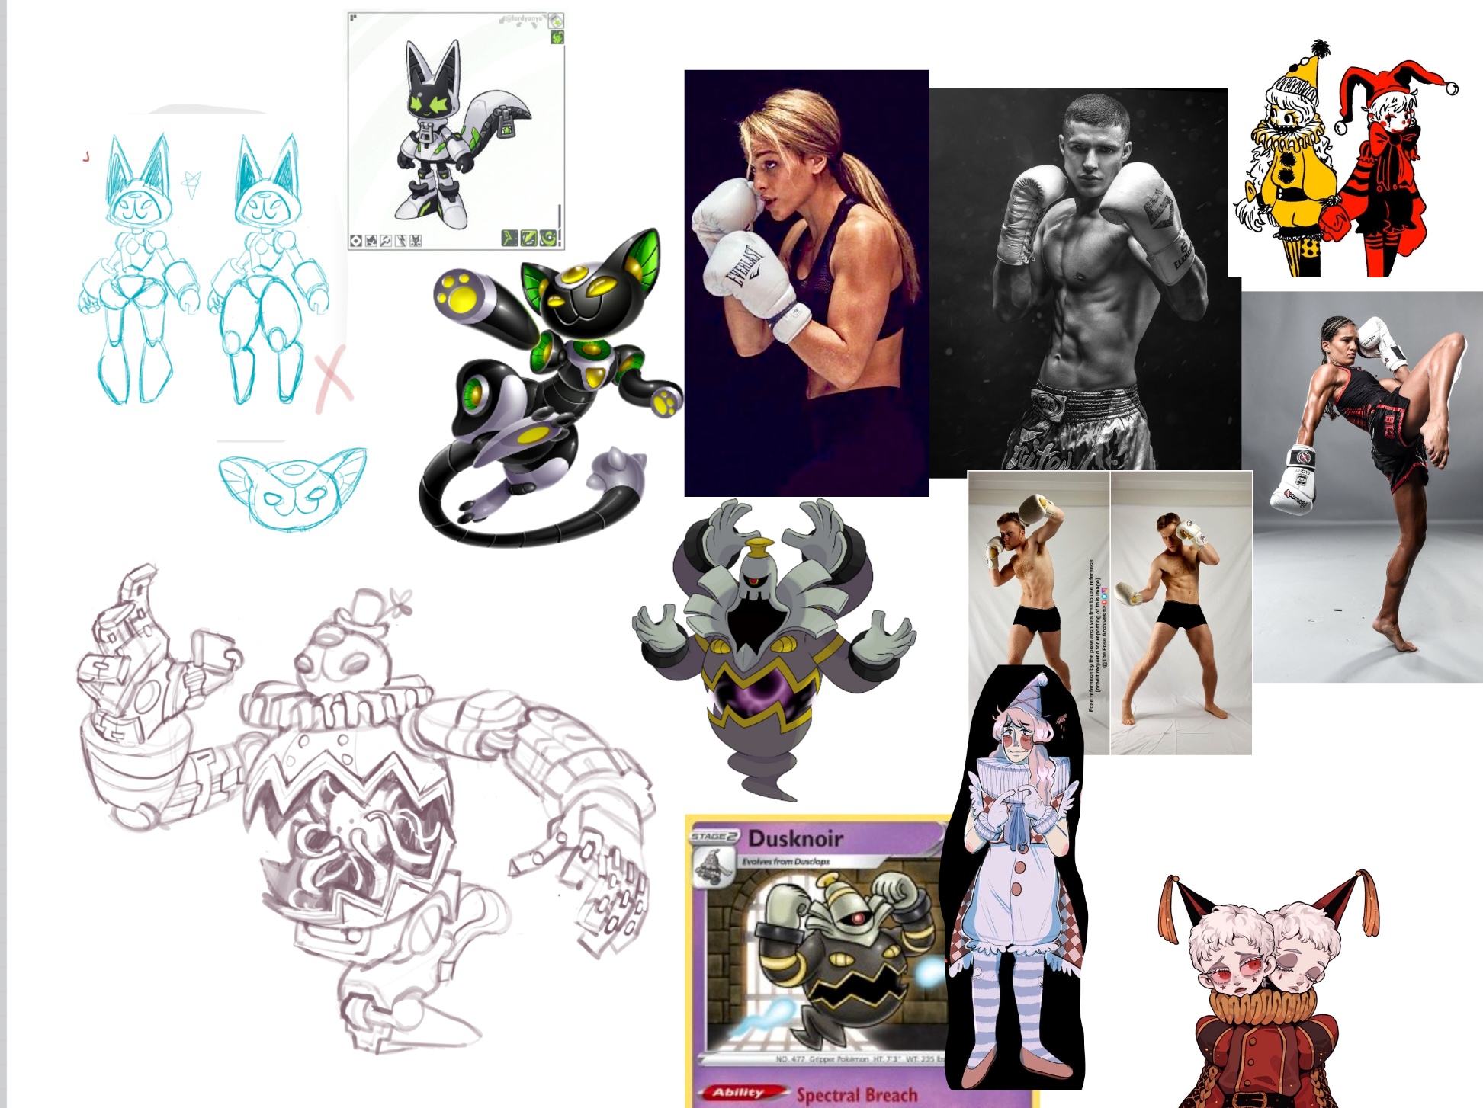

Figure Robot Sketch

Keeping with the clown theme, the colour palette was originally chosen to be vibrant and saturated. However, after testing the colours, it appeared to be too overpowering. As a result, a more subdued and monochromatic colour palette was chosen.

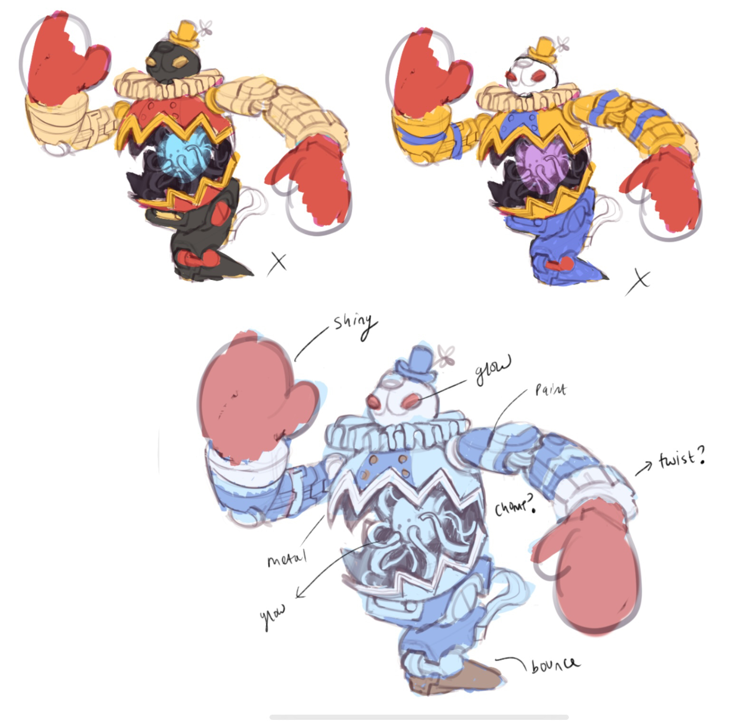

Figure Colour Palette

## **1.2 Olympic Sport - Boxing**

Boxing is the Olympic sport that the Olympoid would perform. Photos of boxing gloves were collected as reference, as well as videos of both real-life and animated boxing matches.

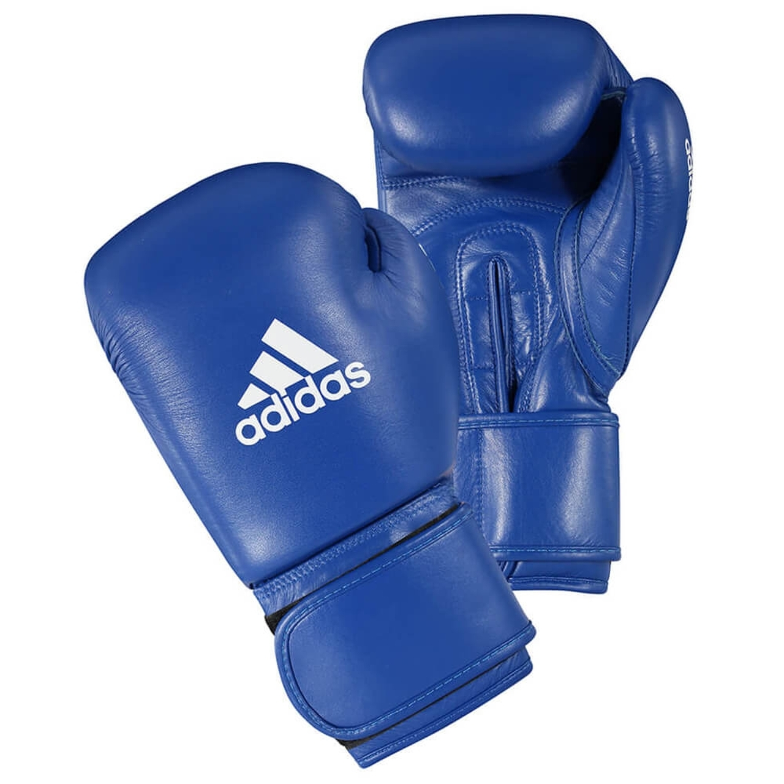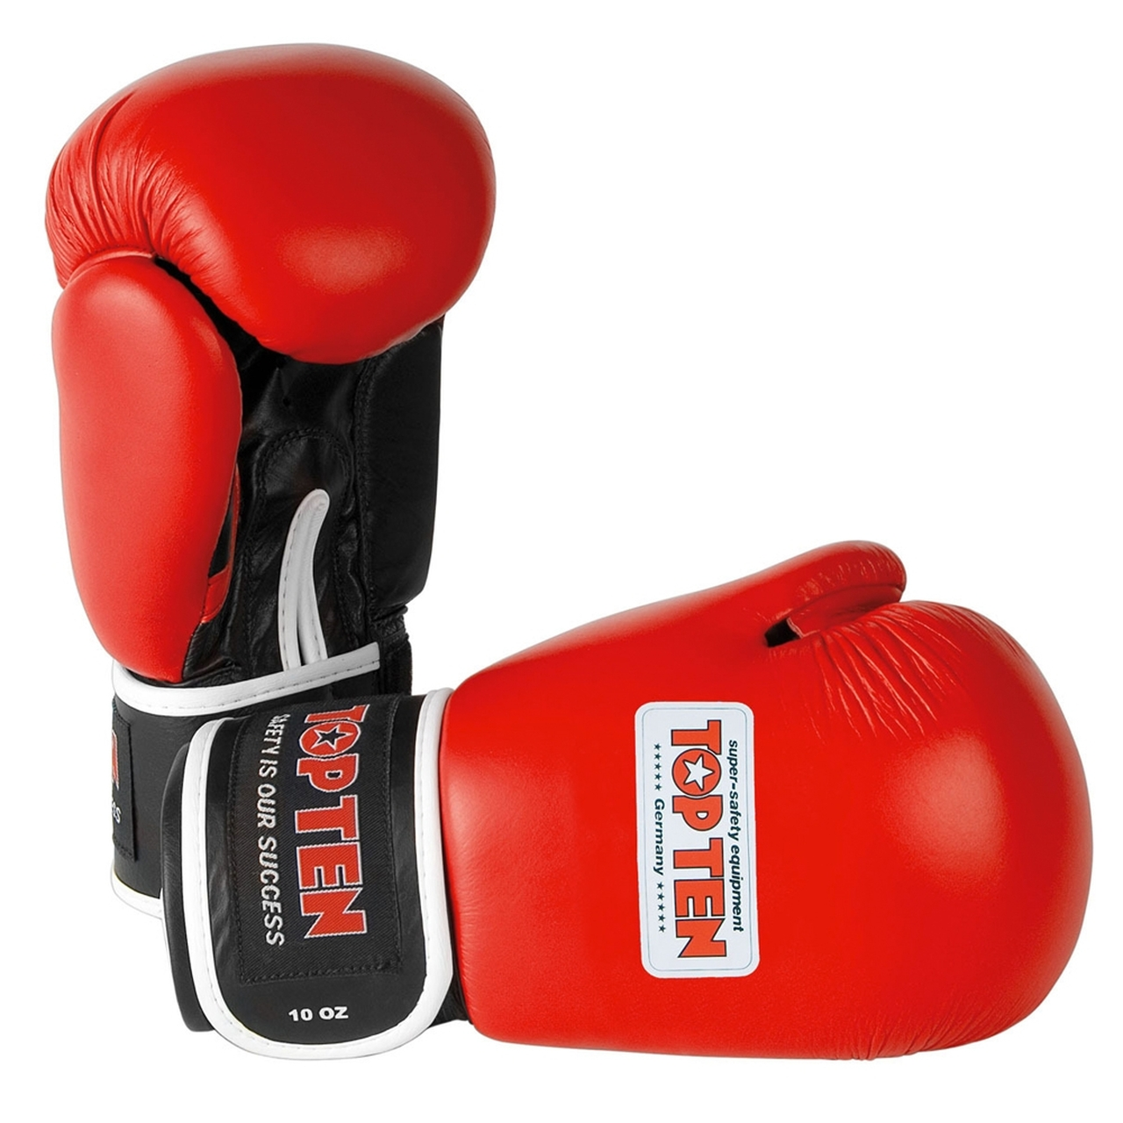

First, in the sketches, the robot clown's hands were replaced with boxing gloves. Then, the robot clown performing the action in the reference videos was sketched. These sketches aided in visualising how the Olympoid would move.

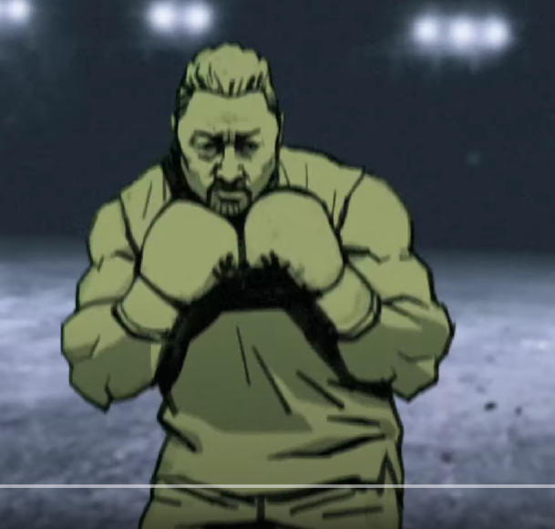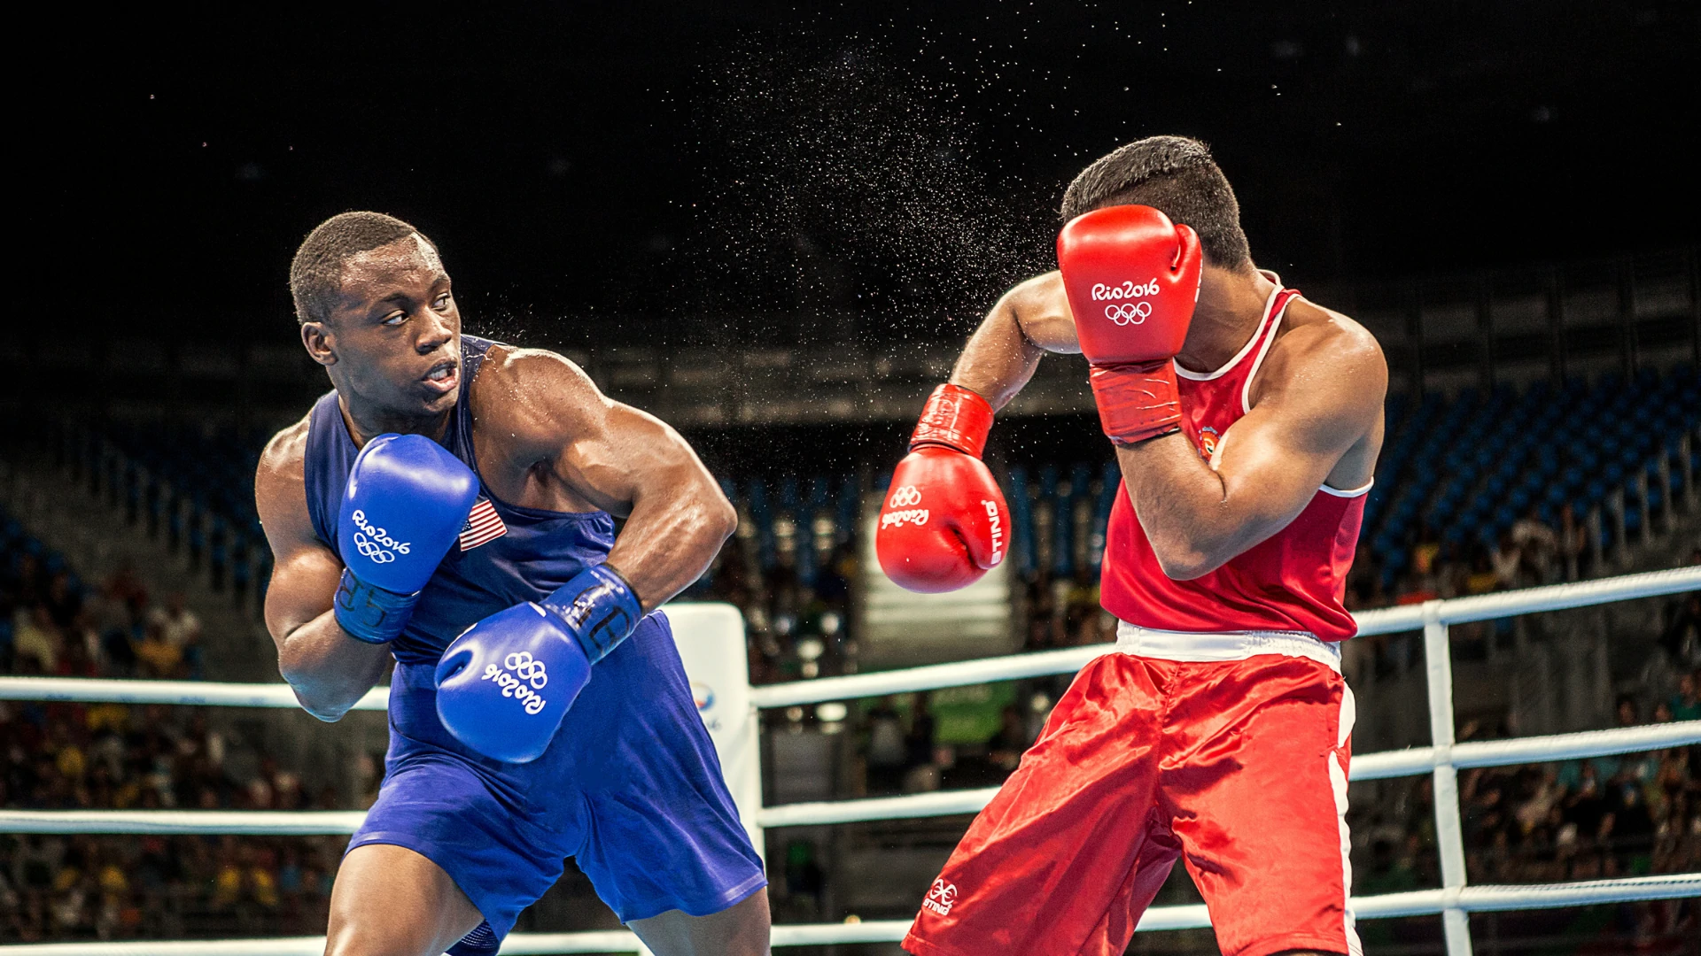

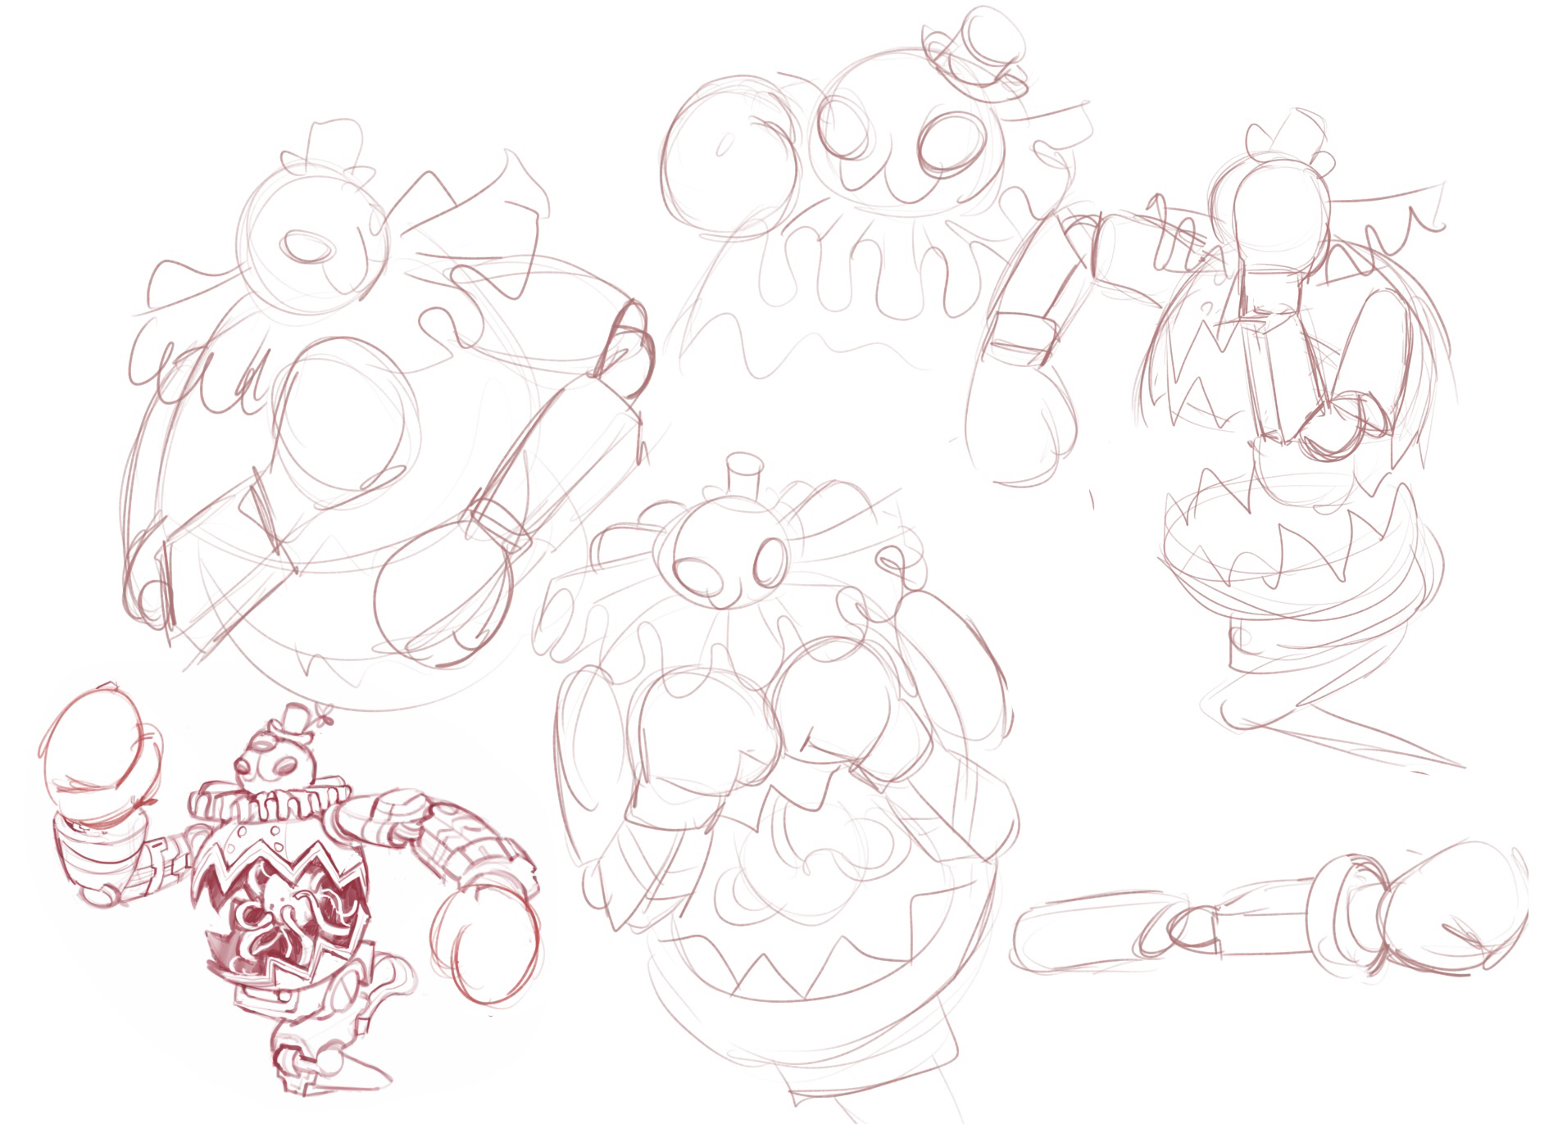

Figure Figure sketches

Lastly, reference photos of the boxing ring were collected for modelling the set.

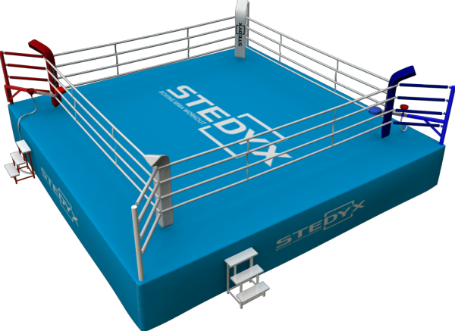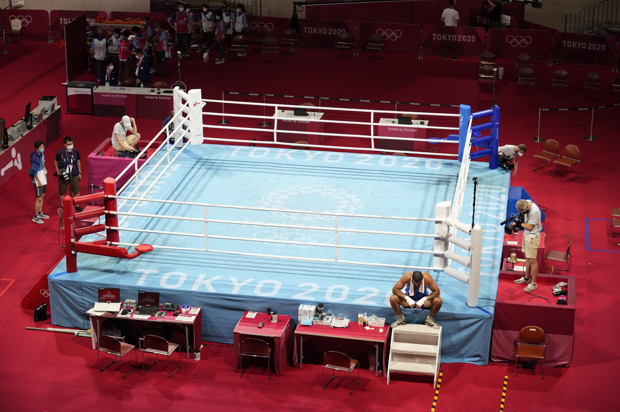

# **Modelling**

## **2.1 Modelling setup**

The Maya workspace was set up prior to modelling. Two image planes were inserted: one of the robot's front view and one of its side view. The images were then placed in a layer, and the third box was set to 'R,' ensuring that they were not accidentally selected while modelling. The reference images would ensure that the model's parts are proportionate and in the right place.

In addition, hard surface modelling research was conducted to better understand how to create smooth and solid surfaces. Some of the techniques were then used to model the Olympoid [2].

**2.2 Character Modelling**

The main body served as the modelling starting point. By removing half of the faces from a sphere, a hemisphere was formed. Then, close to the hemisphere's base, an edge loop was inserted, and vertices were pushed around to create teeth-like edge. Following that, the teeth's faces were selected and extruded to create a thicker trim. Afterwards, the trim was detached from the main body so they could be textured separately. This also ensured that when smoothed, the round structure would not be compromised. Finally, the hemisphere was mirrored to form a complete sphere.

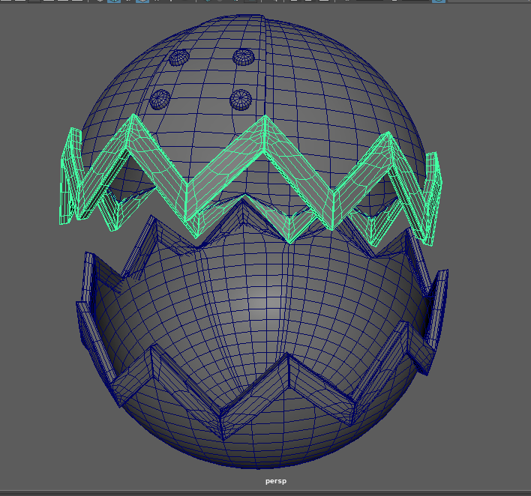

Figure Main body

Only a sphere was required for the Olympoid's head. Faces were removed where the eyes would be, and the edges were "circularised." As the robot's eyes, two scaled spheres were inserted into these holes. To make the mouth, the "multi-cut" tool was used to map out the general shape. Then the cut edges were bevelled in order to carve out the mouth. As edges and vertices were being displaced, the shape of the head became less smooth. There were unnecessary creases and pinching, especially where the edges were close together, such as near the eyes. Fortunately, some hard surface modelling techniques provided solutions to these problems. "Edit edge flow," for example, is a tool that can adjust the position of edges to better fit the curvature of the surrounding mesh. Some of the creasings were smoothed out by selecting problem edges and using this tool. In addition, the "Smooth tool" in the sculpting menu helped to smooth out the mesh even more by averaging the position of all features within the brush radius with all other nearby features. As a result of employing these methods, the mesh of the head became smoother and began to resemble a hard metallic surface.

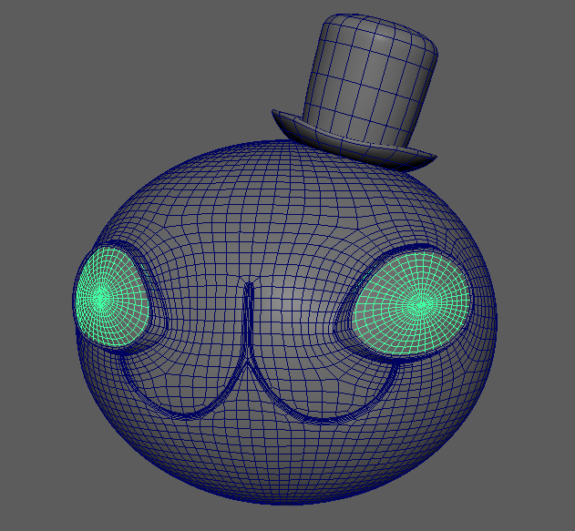

Figure Head

The leg and arms were formed from cube primitives, along with cylinders for the joints. Only one arm was modelled and it was mirrored to create the other arm. To construct the upper arm, a cube was subdivided into six sections and one of those sections was extruded to make the protrusion near the elbow. After that, all of the faces on one side of the upper arm were removed, while the other side was manipulated to be more rounded.

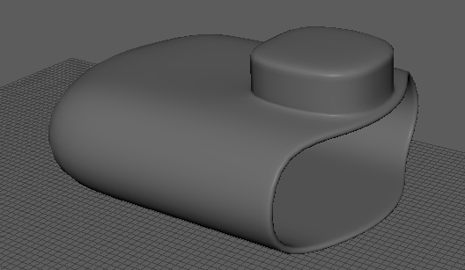

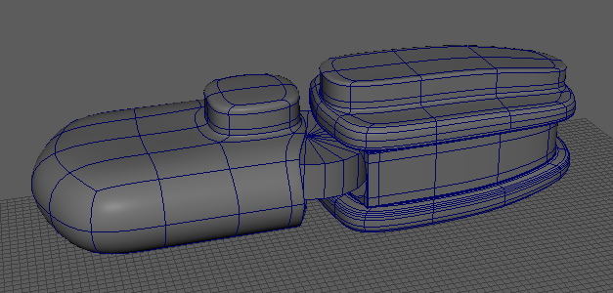

Figure Arms

The forearms and leg were constructed in a similar manner. However, the base of the leg that connects to the main body was designed to be flush against the curve of the main body. This was accomplished by employing a bend deformer, which was the simplest and quickest way to achieve a smooth, even bend. On the other hand, moving the vertices/edges to curve the object, would have taken too long and would not have been as seamless.

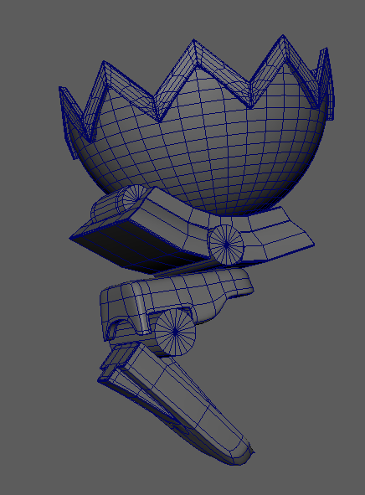

Figure Leg and Hip

To create the boxing gloves a cylinder was extruded until it formed the general shape. From there, edges were moved around and extruded to form the shape of the thumb and bent forefingers. Sculpting tools were utilised to further shape the gloves. For example, the bulge tool helped to pull on the surface for the thumb and the knife tool was used to carve creases into the material.

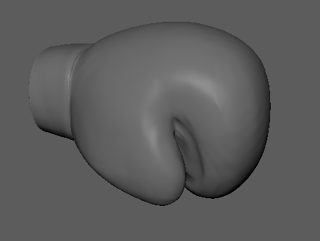

Figure Boxing glove

The gears on the robot's wrist were made by extruding every other outer face of a cylinder. The inner hole was created by selecting the faces on either side and then choosing "Bridge Faces."

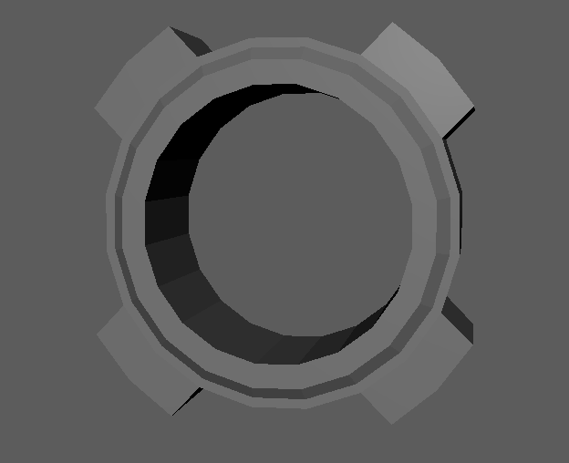

Figure Wrist Gear

Two approaches were attempted for the ruff. To create the folds, the first method was to subdivide a plane and move the edges around. The resulting ruffles appeared inorganic and stiff. Curves were employed in the second method. Using "Loft," two EP curves were drawn and connected. As a result, the ruffles appeared more realistic with more varying folds. It also gave the Olympic design some asymmetry. The ruffles were then wrapped around the Olympoid's neck with another bend deformer. The ruff's surface was then closed by combining vertices. Finally, to avoid non-manifolds and self-insertion, edges were moved and the clean-up tool was used. One of the most impressive aspects of modelling the ruff was the ability to create such a complex shape in such a short amount of time.

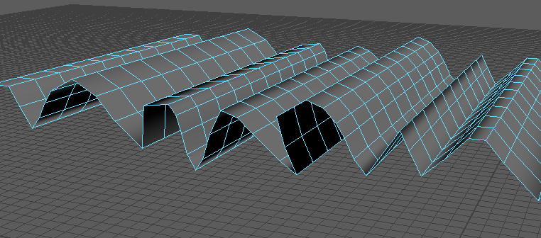

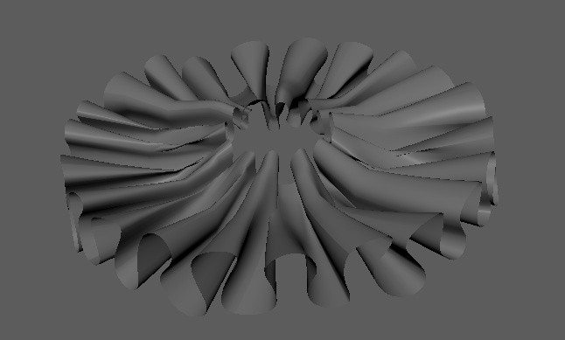

Figure Ruff attempt 1 and 2

To serve as the energy ball, a single sphere was placed inside the main body. Curves were used once again to create the wires protruding from the ball. The EP curve tool was used to map out the overall shape of the wires. A circular plane was then placed at a right angle to the beginning of a curve. The plane was then extruded to follow the shape of the curve after selecting both the plane and the curve. This process was repeated for all of the wires. Using this method, creating the wires was a very simple, and it was much easier to control their shape.

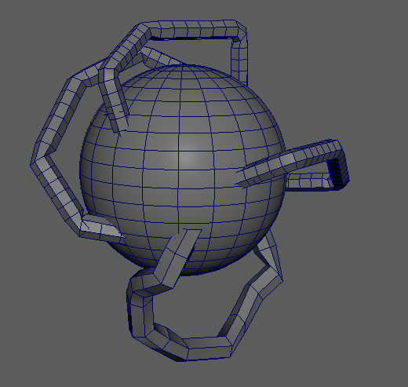

Figure Energy Ball

Finally, the majority of the Olympoid's edges were hardened. This was accomplished by bevelling the edges with "chamfer" disabled, "segments" set to 3-4, and "fractions" set to a very low number. As a result, the Olympoid's components appeared more mechanical and sleeker.

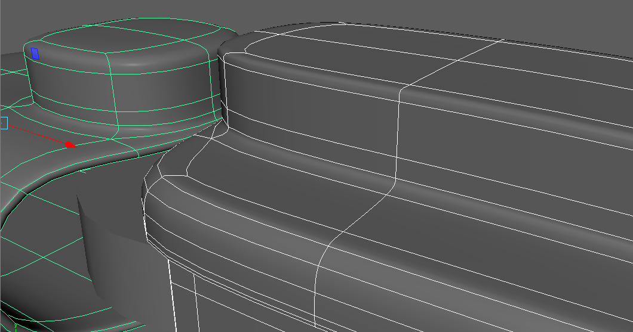

Figure Bevelling

## **2.3 Set Modelling**

The set was built using the references of Olympic boxing rings. The rings base was created from a single cube that was scaled up and subdivided into sixths in width and depth. By selecting the inner top faces and pulling them upwards, a raised platform was created with slanted outer edges. This raised platform was then further accentuated by bevelling its edges with chamfer turned off.

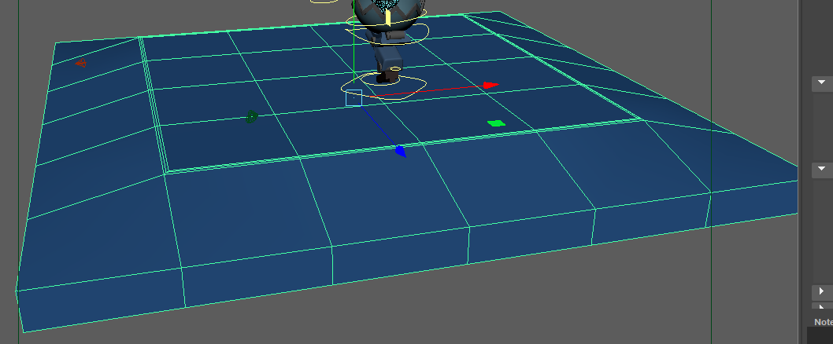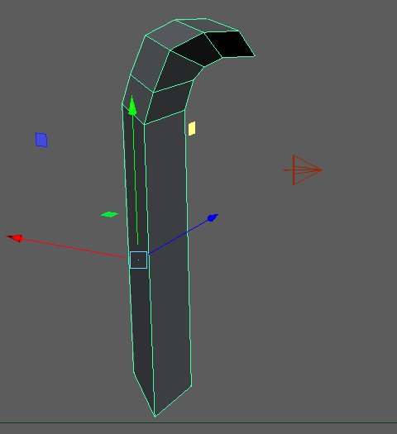

The inner pillars of the ring were then created by cutting cubes into a triangular prism and then elongating them. The top curve was created by extruding the topmost face multiple times and rotating it each time. Finally, the ropes that connect the pillars was made from 4 parallel scaled cylinders.

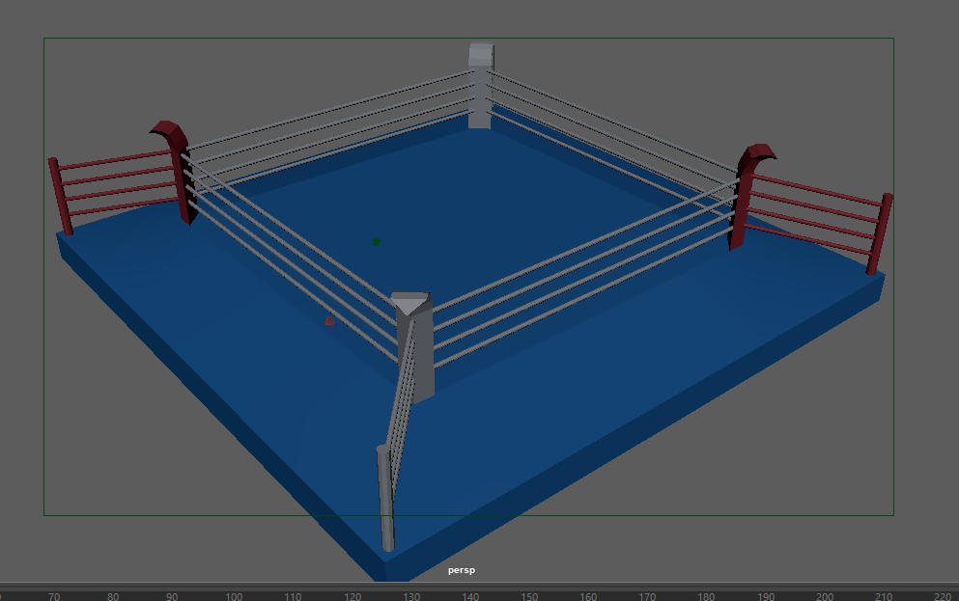

Figure Final Boxing Ring

# 

# **Textures and Lighting**

# **3.1 Shaders and Textures**

To begin, all objects were given the aiStandardSurface material and renamed. To see how the textures will look fully rendered in the Arnold RenderView window, an aiSkyDomeLight object with the base colour connected to an HDR image was added to the scene. [Appendix.33]

It was decided in the final concept design that not every part of the robot would be metallic. Instead, some areas would have a gleaming car paint effect. Other smaller areas, on the other hand, would be covered in a rusty metal material. This proved to be a wise decision because it made distinguishing between different body parts much easier.

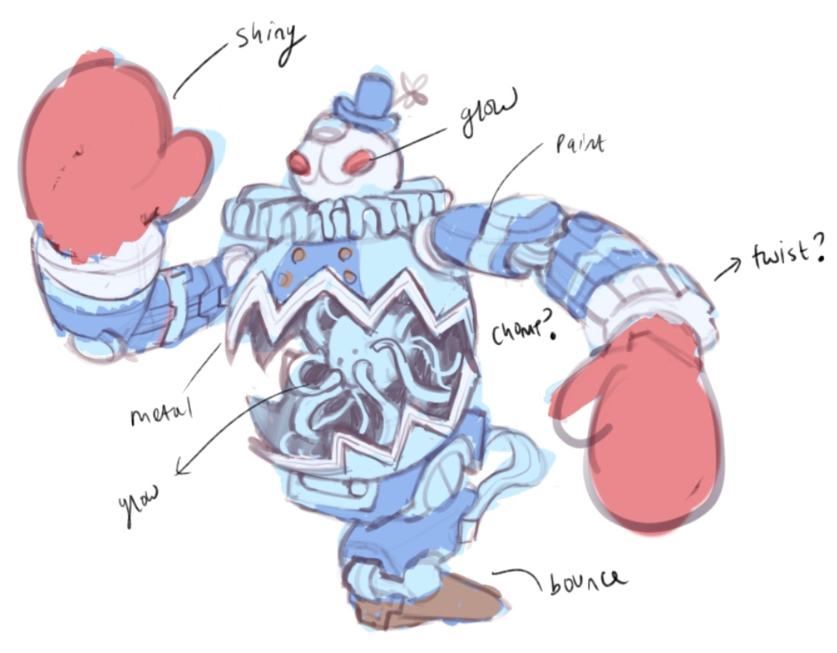

It was relatively simple to create a car paint material. Following the selection of the desired colour, the Coat Weight attribute was set to 1. This resulted in a reflective clear coat on top of the material. It was then applied to the head, main body, arms, and legs. In addition, extra steps were taken to add more detail to those body parts. As shown in the sketch above, the mouth needed to be a darker colour, and the arms/main body needed a single stripe of colour.

There were a few different approaches that were considered for the mouth. The first option was to select all of the mouth's faces and apply a darker material to them. However, because the carved mouth was made by bevelling, there were far too many small faces to select. The second option was to use the 3D paint tool in Maya's Rendering workspace. Unfortunately, this tool was cumbersome and made drawing fine lines difficult. Finally, the third and final option was to UV-unwrap the head (cylindrically) and export the map as a .jpeg into Photoshop. This method allowed for greater precision when drawing the lines and was extremely simple to edit.

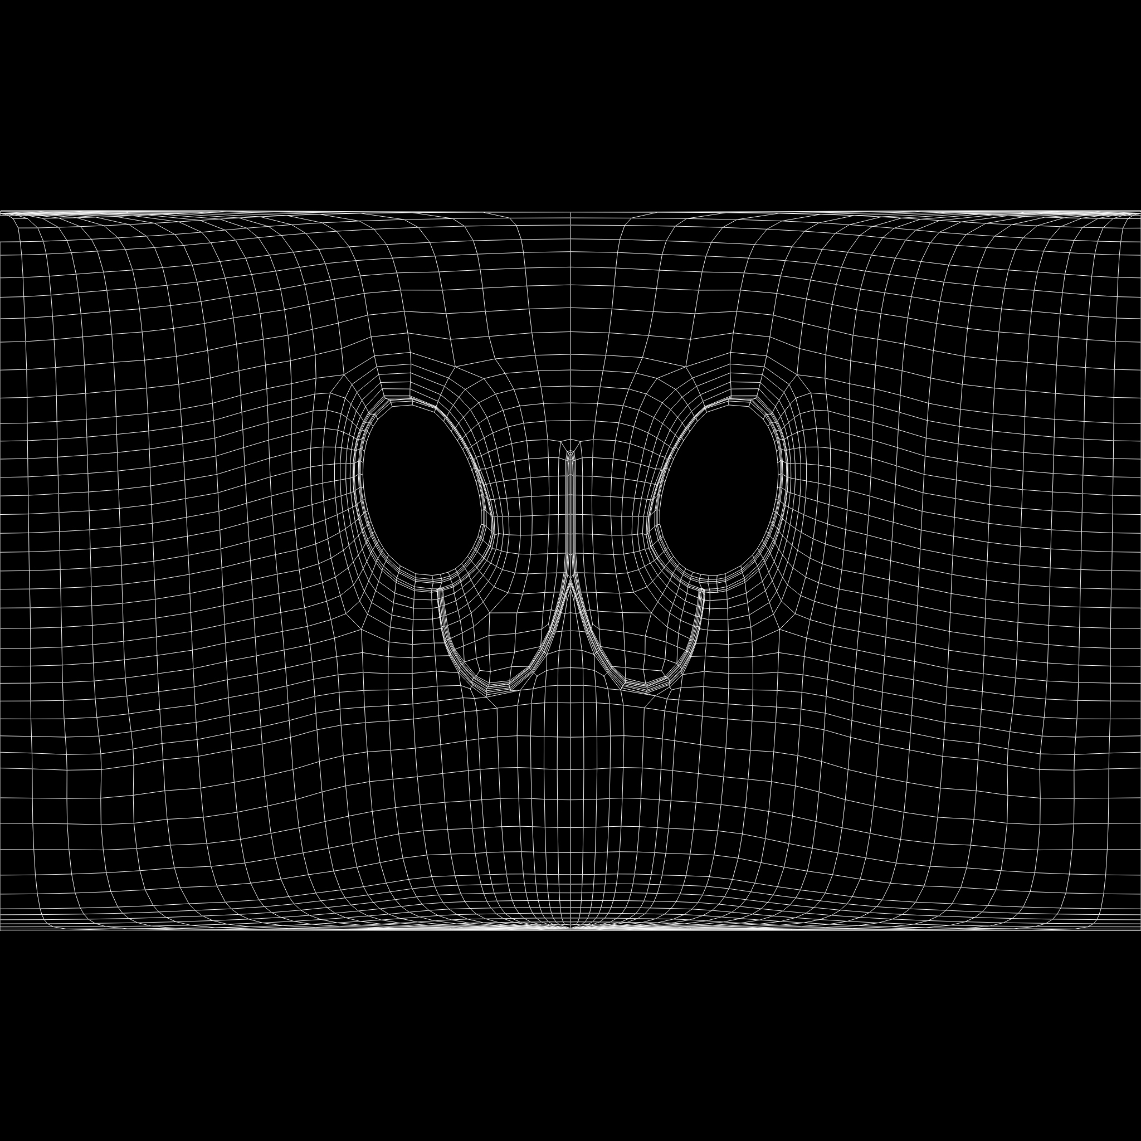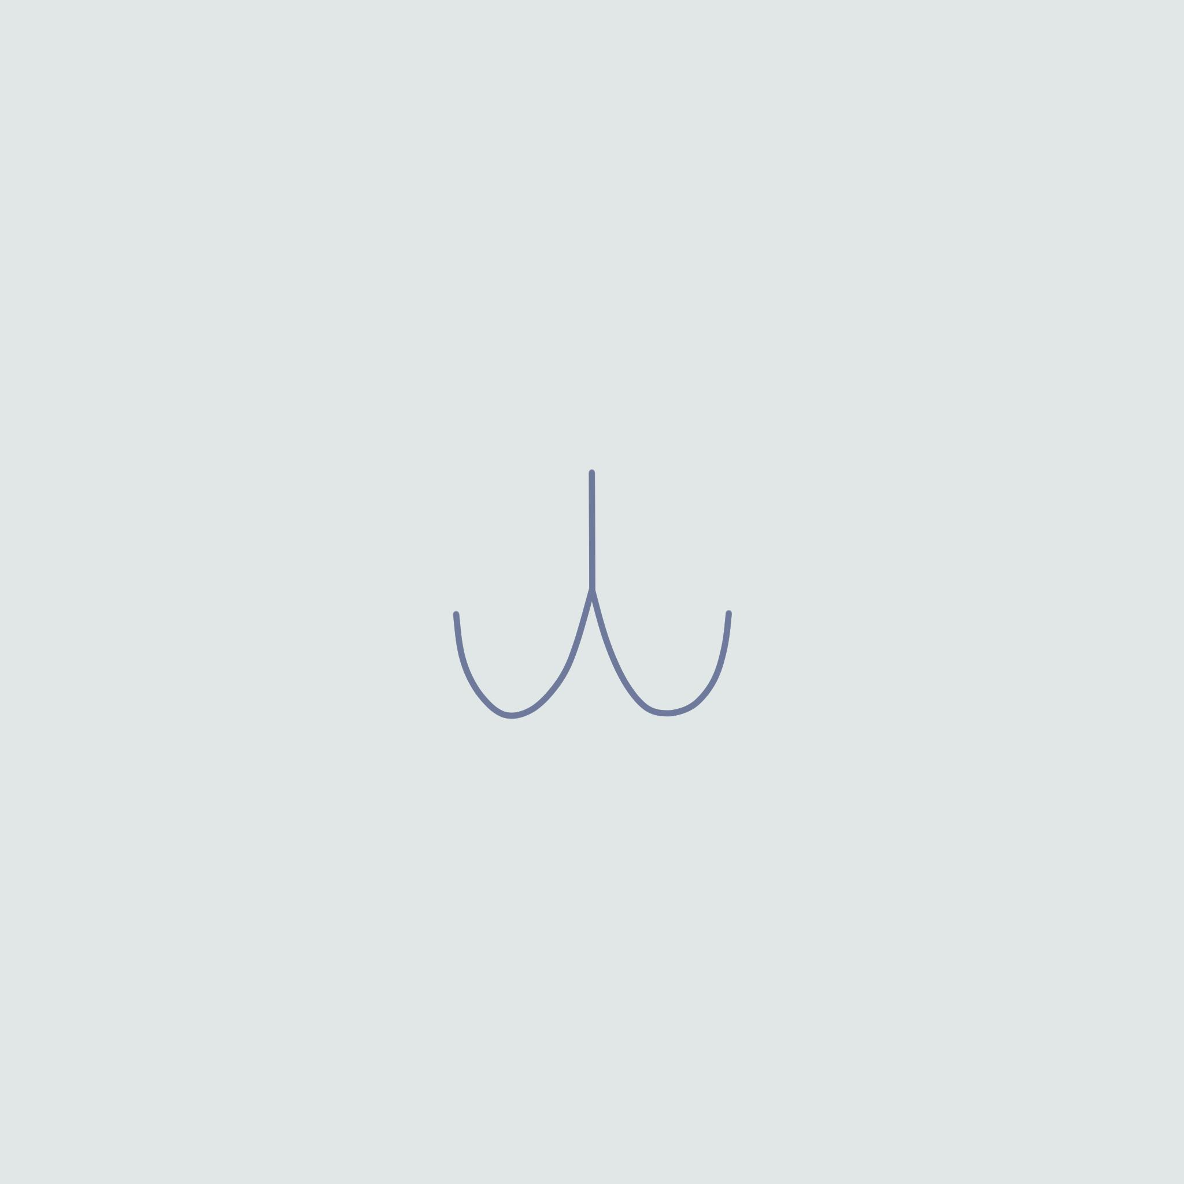

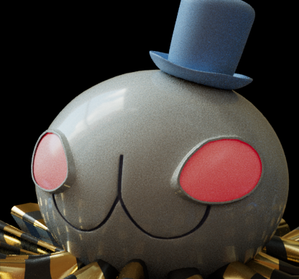

Figure 14 UV map of head

The stripe on the arms and main body was created by connecting the base colour of the material to a colour ramp. The ramp was of the "U Ramp" type, and its interpolation was set to "none" to prevent colour fading. Three nodes were added to the ramp and moved around until the desired stripe shape was obtained.

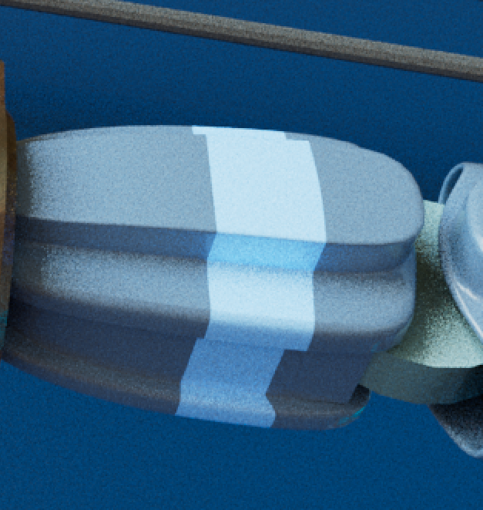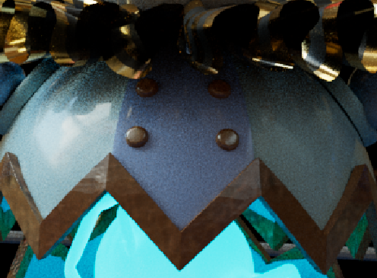

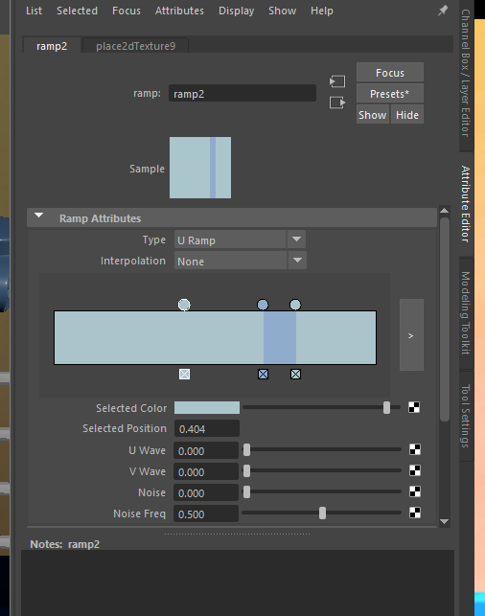

Figure 15 Attributes for arms/main body material

In comparison to the car paint material, constructing a rough metal material required more steps because it was a combination of two shaders. The first shader began with the Brushed Metal preset. A rough metal.jpg texture image was linked to the base colour as well as the bump mapping attribute under “Geometry”. As a result, the metal's surface appeared uneven. The second shader used a different texture image which also was linked to the base colour and bumping map attributes. An aiMixShader node was then used to combine these two shaders. This resulted in a rusty gold metal material. It was applied to the gear wrists, the main body trim, and some of the joints.

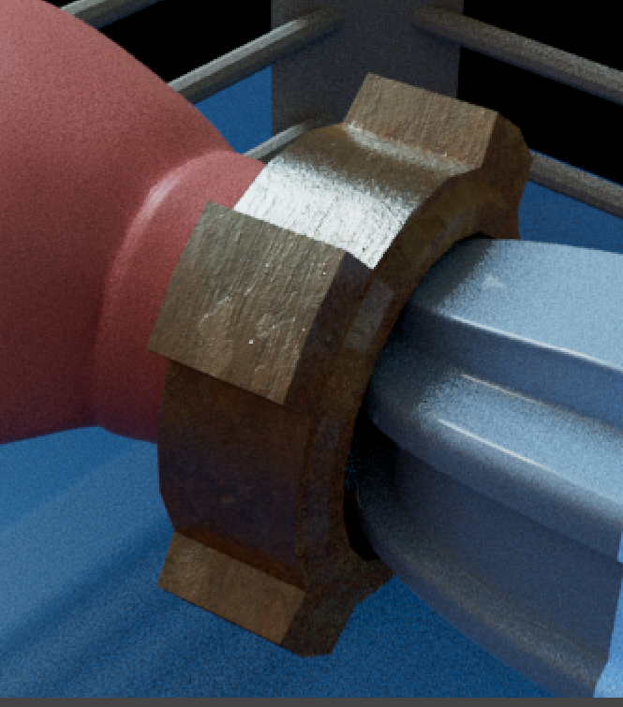

Figure Metal material. See Appendix.31 for the shader graph

Originally, the ruff material was going to be clothe-like. However, it was decided that a stripped, plastic film-like effect would be more appropriate for the Olympoid's aesthetics. Two shaders were again combined to create this material: a metallic gold shader and a matte black shader. A checker texture pattern was altered to create a striped pattern. The alpha output of this texture was then inserted into the "mix" input variable of an aiMixShader node. This resulted in the creation of a mask when combining the two shaders, resulting in the white stripes being gold and the black stripes being matte black.

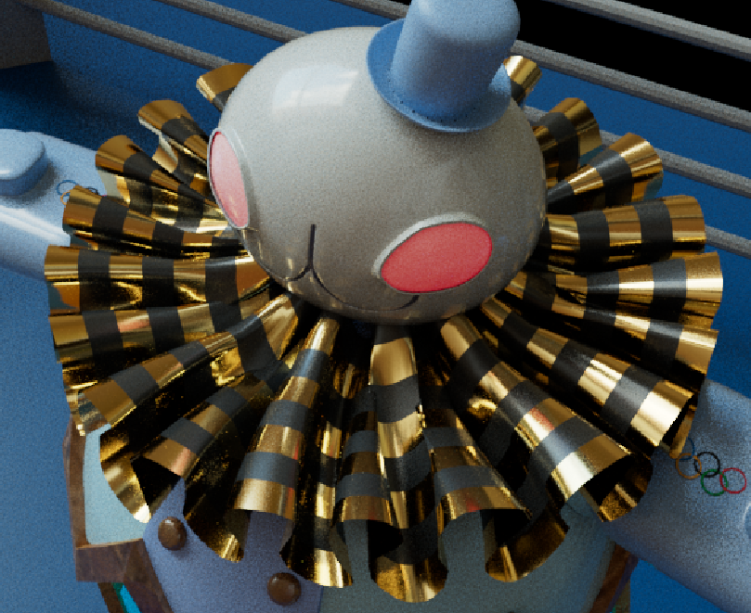

Figure Ruff material. See Appendix.32 for the shader graph

The energy ball was imagined to have a light blue glow in the design. This was accomplished by increasing the emission weight value to 3.000. The robot's eyes also glow, though not as brightly.

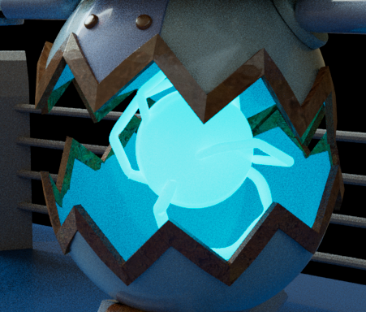

Figure Emissive material

Finally, the Olympic logo was added to both upper arms. A new standard surface material was added to a 4-by-4 plane. As the base colour, an image of the Olympic rings was used. The image was scaled to fit the plane. Finally, the "Deform -> Shrinkwrap" tool was used to wrap the plane onto the surface of the upper arms.

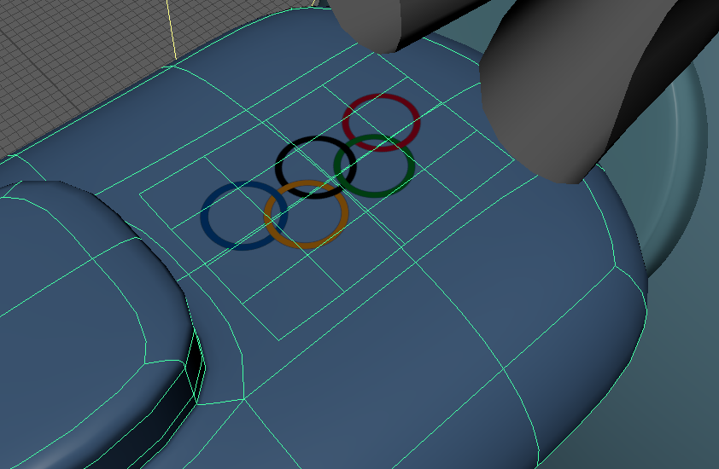

Figure Olympic Logo

## **3.2 Lighting Setup**

## The aiSkyDomeLight had already provided some lighting to the scene. However, the exposure of this light was reduced to create a more dimly lit scene. According to the concept sketches, the atmosphere of the scene is quite dramatic and this was accomplished by using two harsh spotlights. One points down from the top right of the scene, while the other points up from the bottom left. The first spotlight emits a more intense warm orange colour, whereas the second spotlight is blue and has a lower exposure value and a higher cone angle.

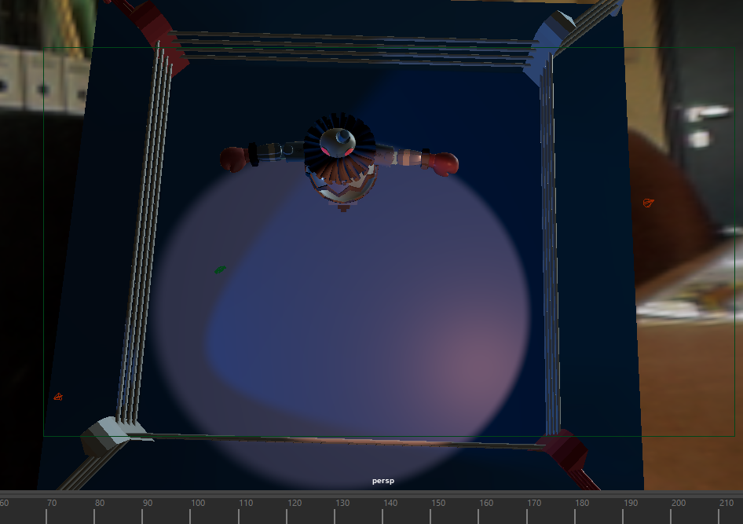

Figure Spotlight setup

The placement of the lights was determined with the camera position in mind. For example, during the uppercut, the model is backlit by a warm spotlight while the majority of its surface is lit by blue light. This contributed to the scene's climactic feel.

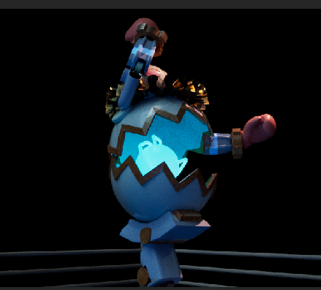

Figure Rim lighting during the climax

# **Character Rigging**

Before beginning to rig, all Olympoid components were grouped and placed in a layer. The third checkbox of that layer was then set to 'R' to prevent the Olympoid from being selected and moved by accident during the rigging process.

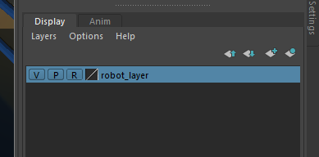

**4.1 Joints and IK handles**

The joints were created after the viewport was changed to "front view." They were placed in all of the usual places, such as the wrists, elbows, shoulders, neck, and so on. However, two extra joints were added to solely control the rotation of the upper and lower parts of the circular body. This would prove useful later in the animation process.

IK handles were created for the arms, leg and spine. The spine IK handle was created to allow for a twisting effect when the chest is rotated.

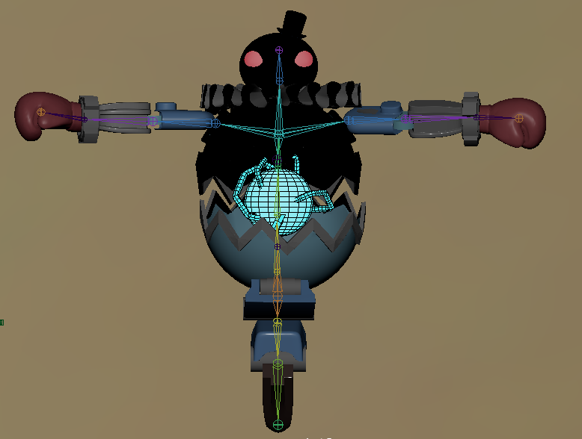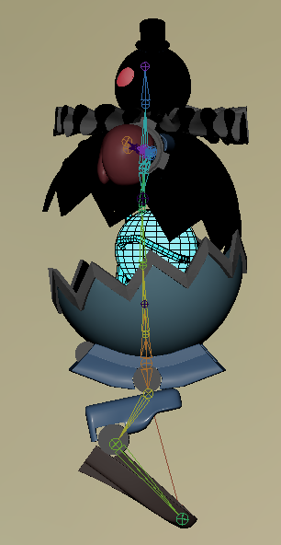

Figure Skeleton

The joints were all oriented to face the correct direction to make the rigging and animating process easier. To mass orient all the joints, a Coment Cartoons MEL script called cometJointOrient() [Appendix.34] was used.

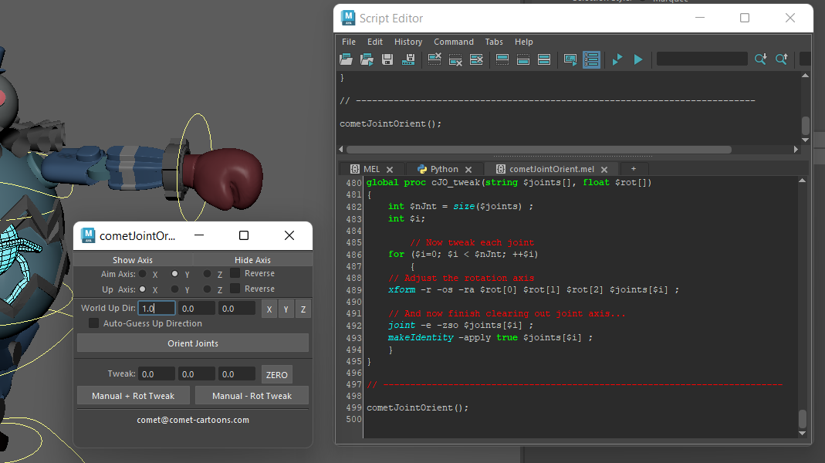

**4.2 Controllers**

The next step was to create joint controls. These are the objects that will be animated, as their transformation values will begin at zero, unlike the joints. The controllers were circle NURBS that were positioned over the relevant joints. Their transformation was frozen after they were vertex-snapped to the joints and correctly oriented.

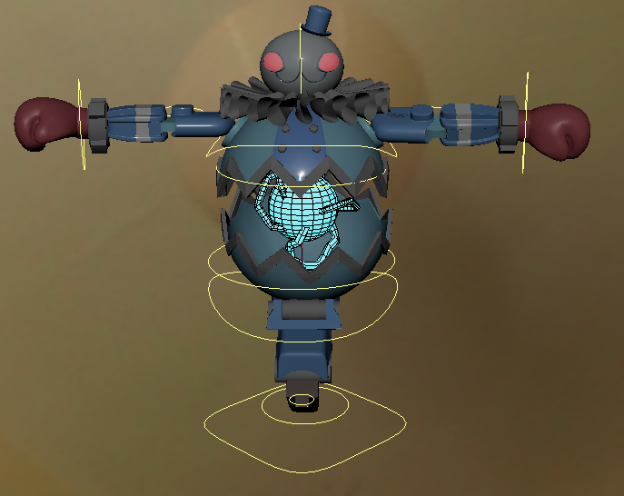

Figure Controller setup

The constraints used by the controls drive the joint structure. A Point and Orient constraint were applied after selecting both the hand controls and the arm IK handles. This enabled the controllers to translate and rotate the hands. However, for the leg controller, only a Point constraint was required. Similarly, only an Orient constraint was required for the controls for the head, top, and bottom halves of the main body.

The connections editor was used for the hip and chest controllers. The connection "Rotate y -> roll" was established between the hip controller and the spine IK handle. The connection "Rotate y -> twist" was then made between the chest controller and the spine IK handle. With this configuration, the hip could rotate the spine in all directions and the chest could twist independently of the hip.

Additional controllers for the elbows and knees were developed to provide greater control over the arms and legs. Unlike the other controllers, these would be placed behind the joints rather than on top of them. A Pole Vector constraint was applied to these controllers, which causes the end of a pole vector to move to and follow the position of an object.

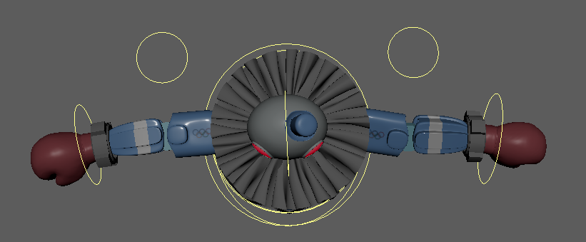

Figure Elbow Controllers

Finally, the main controller was built to house all of the other controllers. This was useful when moving the entire body of the Olympoid, as well as its controllers.

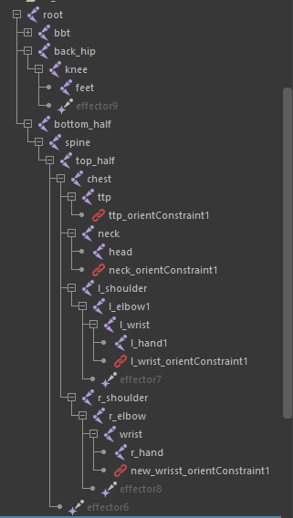

**4.3 Weight Painting**

Weight painting was used to clean up which joints affected which geometry after the skin was bound to the joints. There was no need for a soft gradient for the weights because the robot is purely mechanical. For every single joint, entire sections of the body were chosen and flooded. This was done because, prior to weight painting, parts of the body were being distorted. For example, parts of the ruff were effected when the neck controller was rotated. To fix this, the head, hat, and eyes were selected and then flooded with the weight painting tool, as shown in figure 24. When the neck controller is rotated now, only the white areas are affected. This was repeated for all of the joints.

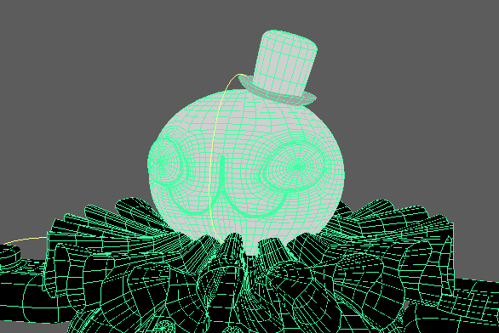

Figure Neck joint weights

1. **Animation**

## **5.1 Storyboard**

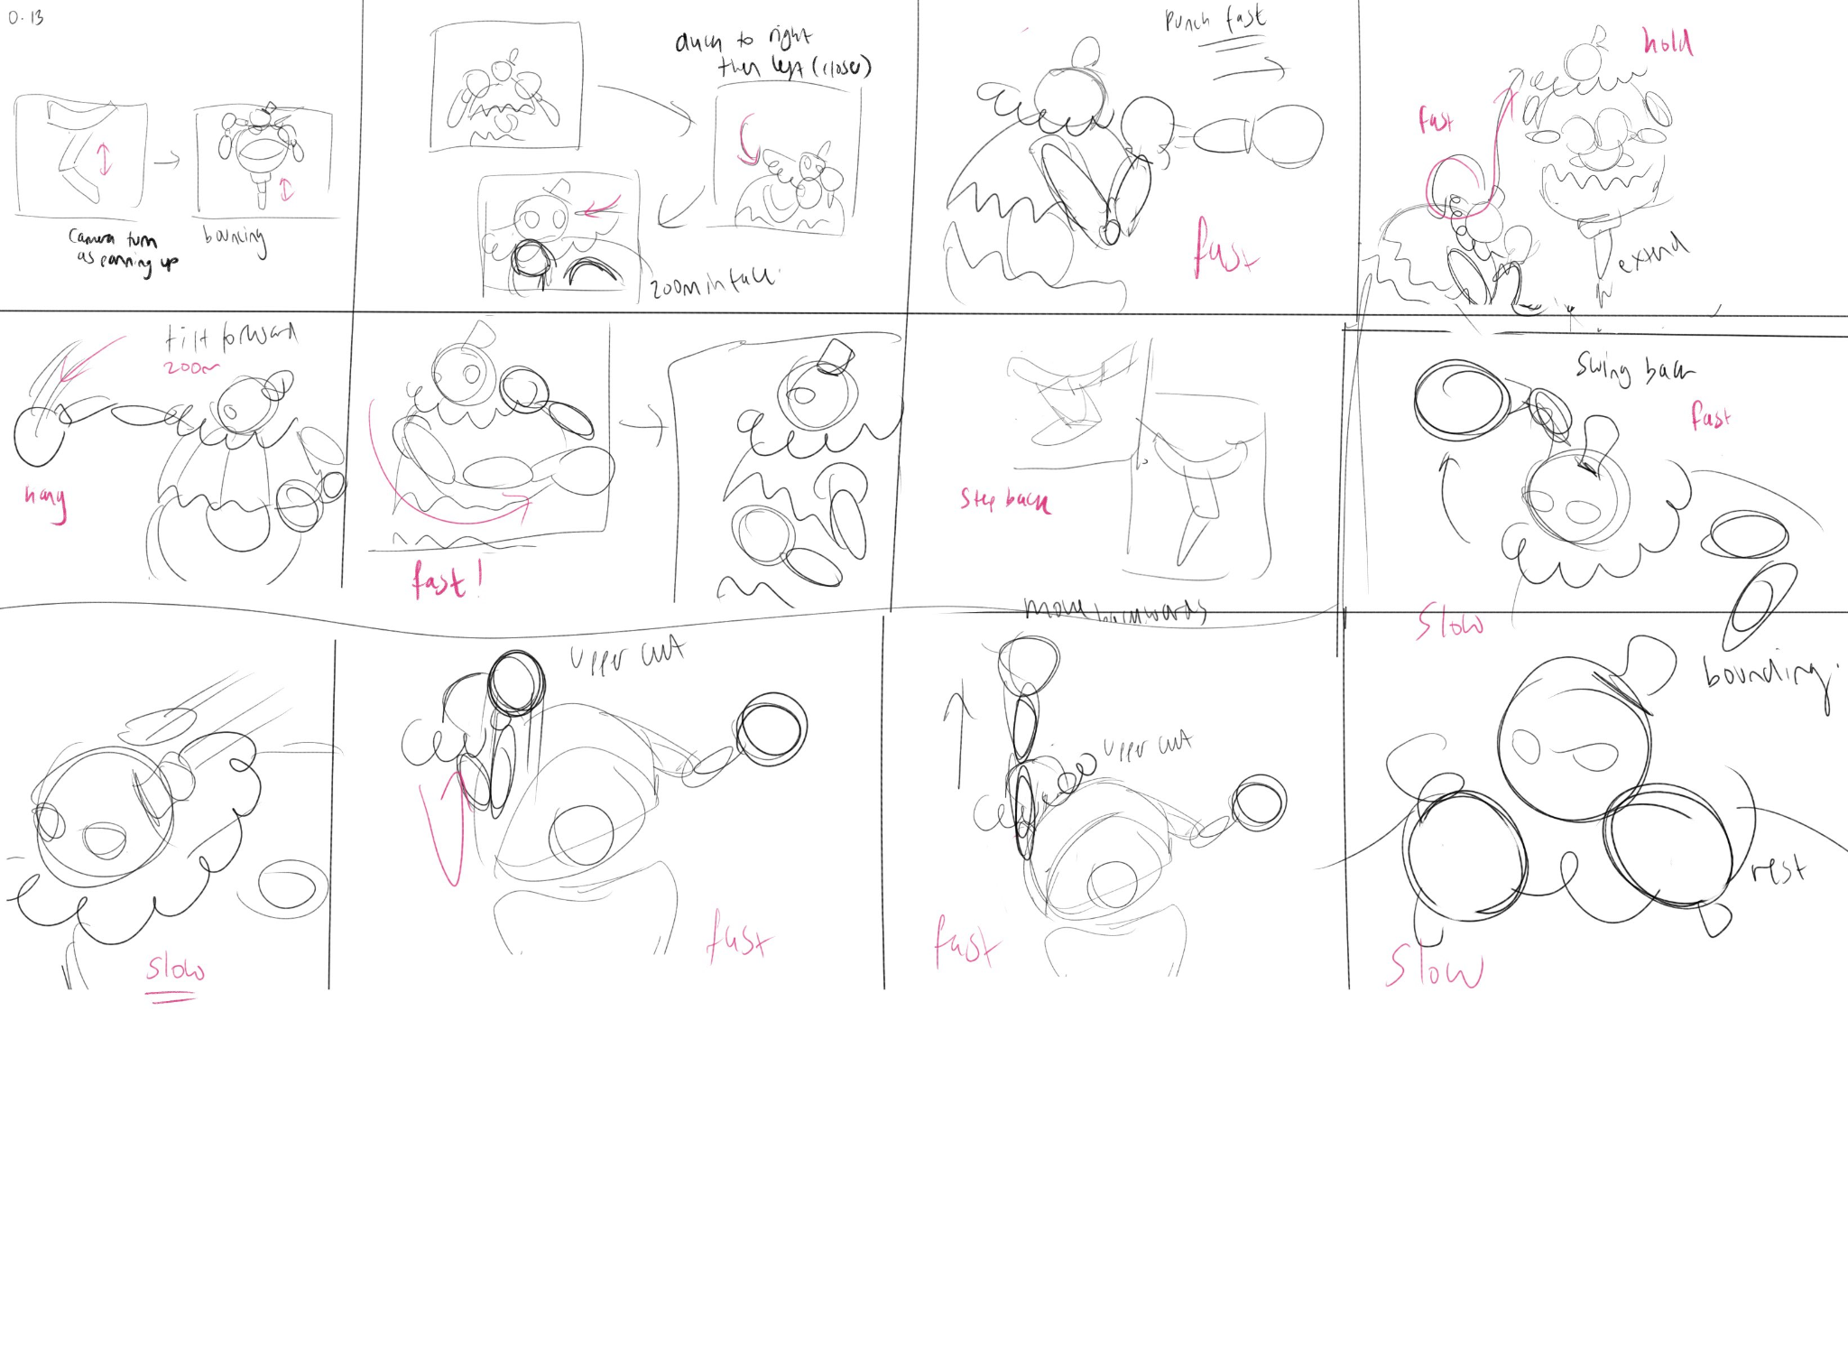

The storyboard for the animation is shown above. It includes both the character movements and the camera angles for each segment. Notes were added to each frame to specify how each action should be performed. This was extremely useful during the animating and shot production processes because the flow of the actions was very clear. The animation aimed for fast-paced action while showcasing various punching styles while adhering to Disney's animation principles.

## **5.2 Character Animation**

The first keyframe that was set was the Olympoid in a T-pose with all of its controller's transformations set to 0. This ensured that if anything went wrong during the animation process, the robot could be reset to its default position. The actual animation begins at frame 10.

Following the storyboard, the main keyframes for the entire animation were set. This ensured that the animation's flow and timings were not disrupted. Following that, the timeline was combed through and new keyframes were added to add more detail to the movements.

Boxing is a sport that requires quick, nimble movements, which was difficult to replicate. Occasionally, when the elbow controllers were moved, the hands would twist in unnatural ways or completely glitch.

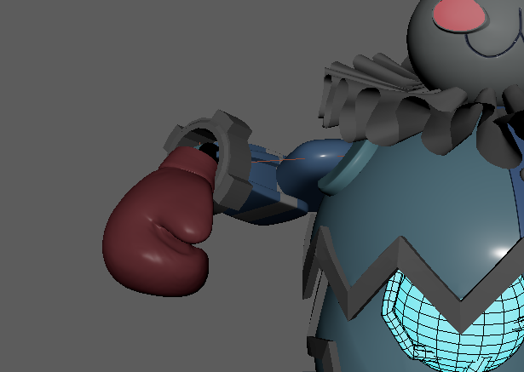

Figure Hand deforming

To address this, the frequency in which the hand's orientation was changed was kept to a minimum. When a new frame for the arms was set, the controller was first translated to its new position, and only then was the hand rotated. If the frame was an in-between frame, the rotation value had to flow nicely from the previous value into the next rotation value. For instance, 90° to 45° to 0°.

**5.2.1 Ease-in and Ease-out**

The keyframes for the punches were edited in the animation graph editor. Frames where the punch is at its climax were set to 'Linear' rather than 'Spline' because there was no need for easing in and out. However, the keyframes just before and after did use 'Spline' to facilitate acceleration and deceleration, which aligned with Disney's 6th animation principle: ease-in and ease-out.

This principle was applied throughout the project. For example, every frame that was set for the bounces used "Spline." This resulted in the bounces appearing as if they had more weight to them. This principle is most visible, however, in the final climactic uppercut. As the robot draws its arm back, its movements slow down and this position is maintained. Slowly, the robot brings its hand forward in an arch motion before accelerating upwards into the final blow.

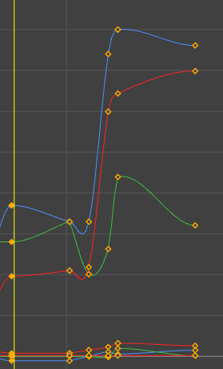

Figure Graph editor - uppercut frames use "spline"

**5.2.2 Follow through and overlap**

'Follow through and overlap' was another of Disney's animation principles that was used. The Olympoid could only move around by bouncing as it only had one leg. These movements, however, could easily feel stiff and unnatural, so mini bounces were added after each major bounce. Doing so made the movements feel more fluid since none of the actions ended abruptly. It also aided in the transition from one action to the next.

**5.2.3 Exaggeration**

It was previously stated that special joints and controllers were developed to control the rotation of the top and bottom halves of the main body [4.1]. As a result, they could be animated in such a way that they appear to be influenced by movements of other body parts. This aided in exaggerating the magnitude of certain actions. For instance, during the final uppercut, the right arm should be extended up with great force. Simultaneously, the upper half of the main body reacts by tilting upwards, emphasising the power of the punch. After the climax, the robot returns to its original stance. The head is the first to fall, followed by the arms, and then the chest.

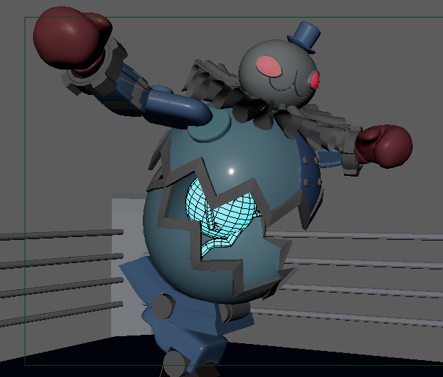 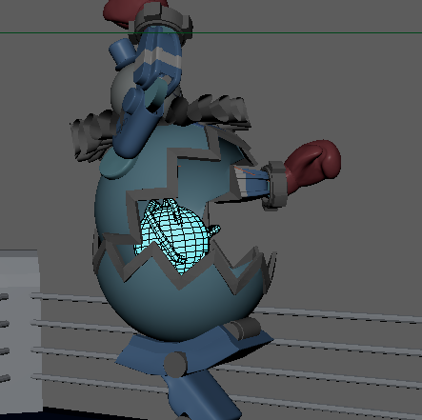

Figure Upper-half tilting upwards

## 

## 

## **5.3 Shot Production**

## A new perspective camera was added to the scene called Render_Camera and a new panel in the workspace was added to use it. The view was then set to 'Resolution Gate,' so that the panel displayed exactly what would be rendered. This was useful when deciding on the composition of the shot.

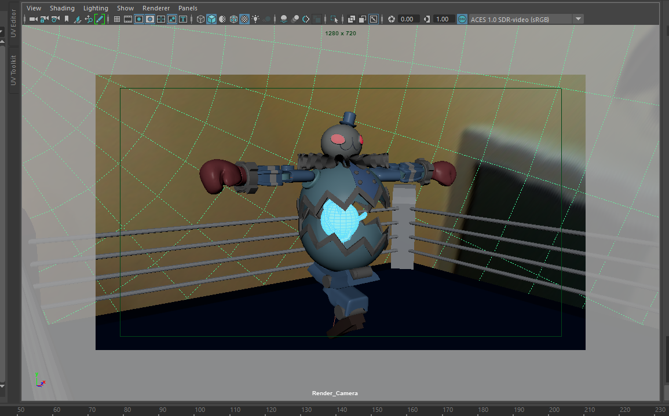

Figure Resolution Gate

## The animation begins with the camera panning up from the ground as the robot bounces on its leg. As if avoiding an attack, the robot quickly dodges to the right and then to the left. Because these actions are so quick, the camera was set to lag behind a little to emphasise the speed. The keyframes for when the camera changes direction were set at least one or two frames after the robot had changed directions.

## 

## The shot after is a sharp punch from the side that transitions into a front arm swing. Similar to before, these actions are very quick and so the camera jump-cuts between them to emphasise the speed and sudden movements. This jump cut was created by changing the set keyframes to be ‘Tangent -> Stepped’ in the animation graph editor.

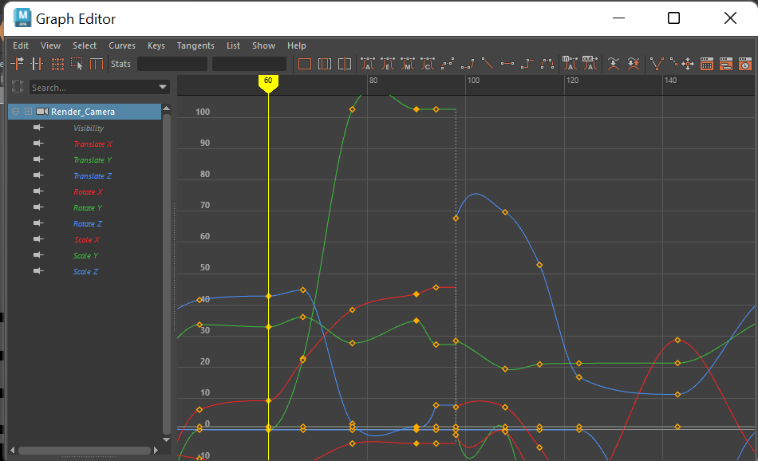

Figure Graph editor - camera jump cuts

Following that is a shot of the robot's leg as it bounces. This shot builds anticipation for the final attack which is an uppercut. The camera zooms in on the robot's face as its arm swings back. To heighten the suspense, the shot on its face was held for a second while it slowly brought its hand forward. Immediately following, the camera jump-cuts to a side view of the uppercut. The camera also shakes slightly, almost as if it has been hit. Finally, as the robot returns to its original stance, the camera will zoom back into its head.

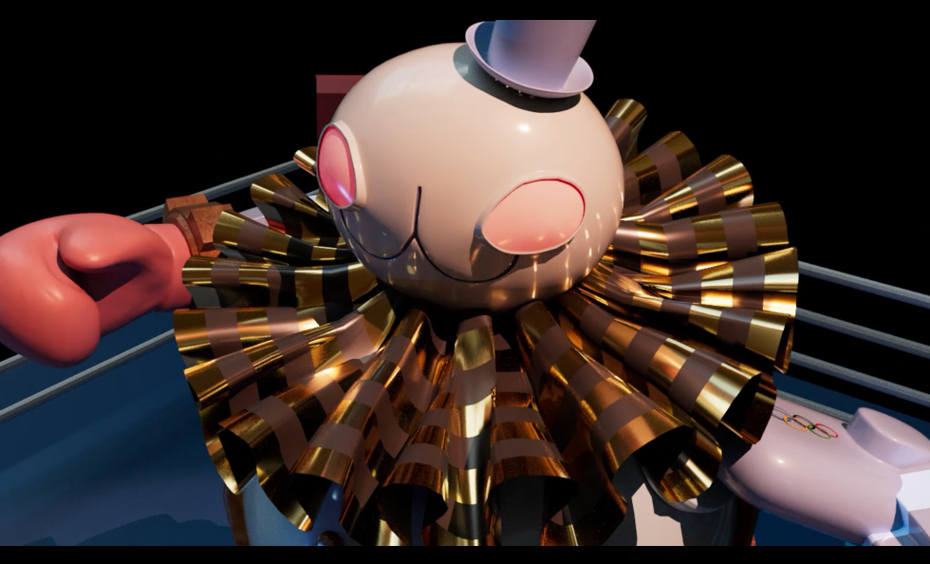 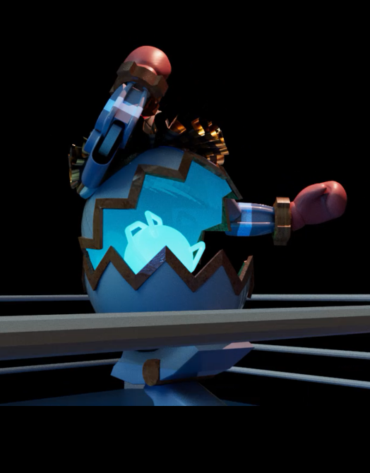

Figure Camera during uppercut

# 

# **5. Personal Evaluation**

Throughout the course of this project's life cycle, many lessons were learned. Therefore, there were a few things that, in retrospect, could have been handled differently. One of the highlights of this project would be modelling and texturing the ruff. This is because it was fascinating to see how such a complex-looking object could be created in such a short amount of time. Other areas that appeared to be much easier to model proved to be far more difficult. For example, modelling the main body to have teeth-like edges warranted careful planning in order to avoid pinching and creasing in unnecessary places. As a result, it became abundantly clear how critical clean geometry was. It not only looks better, but it also makes the rigging and animating portion smoother. To achieve clean geometry, it's essential to not be afraid to start over because it will save a lot of time.

Another aspect that could have been improved upon was to incorporate Disney's first animation principle, squash and stretch, to make the animation more dynamic. Deforming the boxing gloves, for example, could have nicely exaggerated the force behind each punch. It would also have created a visual distinction between the flexible material used for the gloves and the hard material used for the rest of the Olympoid's body. Furthermore, secondary animation could have been added by continuously turning the gears on the wrist. This would have increased visual interest, especially since the arms were almost always in frame.

# 

# 

# **References**

1. Wire tutorial: [(447) How to Quickly Model a Wire/Cable using Maya 2018 - YouTube](https://www.youtube.com/watch?v=4igTVJOEJw0)
2. Hard surface modelling techniques: <https://www.youtube.com/watch?v=bQqr8ImjScU&list=WL&index=33&t=1005s>
3. Rusty metal tutorial: [(469) Arnold Shaders CorrodedMetal with AiMix + AmbientOcclusion - YouTube](https://www.youtube.com/watch?v=M8y5Sg_eV9w&t=86s)
4. Stripey material tutorial: <https://www.youtube.com/watch?v=Ho3RUYVPMac>
5. Script to orient joints in mass:<http://www.comet-cartoons.com/melscript.php>

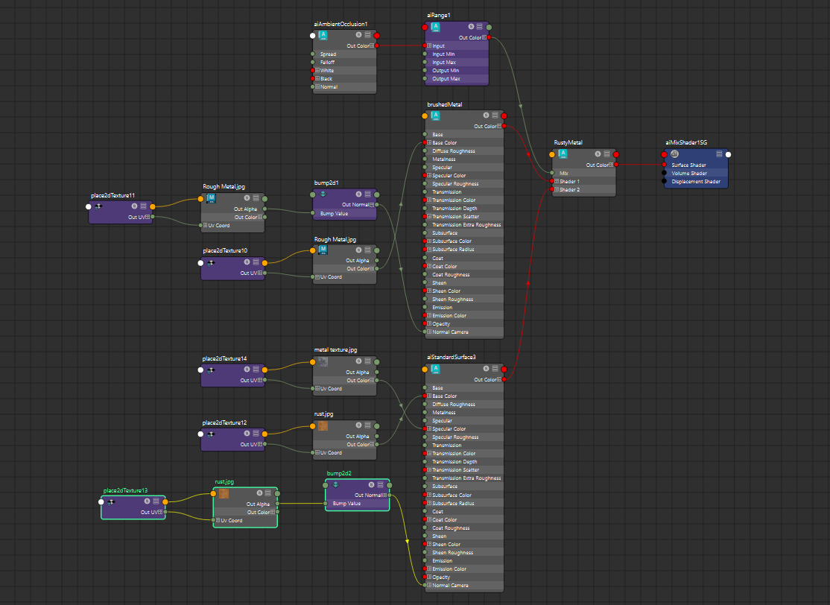**Appendix**

Figure Rusty metal shader graph

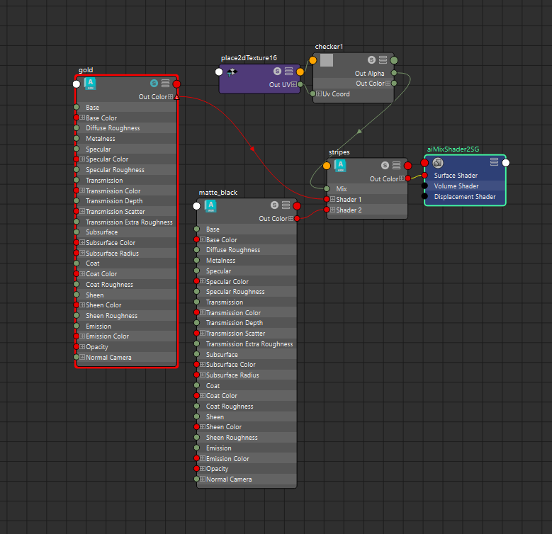

Figure Gold and black stripes shader graph

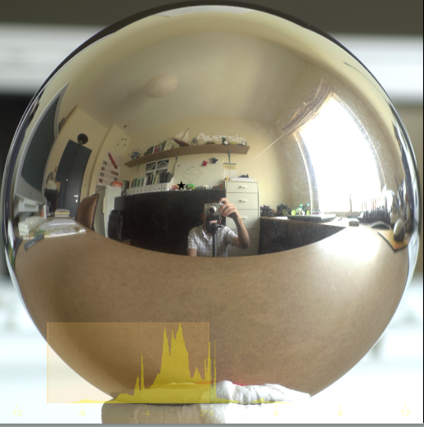

Figure 34 Mass orient MEL script

Figure 33 HDR image